Lecture 8.

Acquired (specific) immunity. Antigens, its types. Antigenic structure of the microorganisms. Antigens of the human organism. Human immune system, organs and tissues, immuncompetent cells

The purpose of the lecture: To acquaint students with specific immunity, its types and forms. Give them information about antigens and their types and characteristics. To inform students about the organs and tissues of the immune system, immunocompetent cells and their functions.

Lecture plan:
1. The concept of specific immunity, its types.
2. Antigens
- Chemical composition, properties (foreignness, antigenicity, immunogenicity, specificity) and types: complete and incomplete antigens; hetero-, iso-, auto-, allo-antigens; T-dependent and B-dependent antigens, superantigens.
- Antigens of the human body, antigens of the Main Hystocompatibility Complex (MHC), its classes and functions, the role in the immune response. CD-antigens.
- Microbial antigens (O-, H-, K-, Vi-antigens of bacteria, protective antigens, toxins, viral antigens).
3. Immune system
4. Central and peripheral organs of the immune system. Immunocompetent cells (regulator, effector, antigen-presenting cells, T and B lymphocytes, CD markers) and their role in the immune response
5. Information about other cells of the immune system (phagocytes, dendrites, eosinophils, basophils, barrier cells).

Antigen-Specific Immune Responses Definitions
Adjuvant: substance that promotes immune response to immunogen
Antigen: substance recognized by immune response
Carrier: protein modified by hapten to elicit response
Epitope: minimal molecular structure recognized by immune response
Hapten: incomplete immunogen that cannot initiate response but can be recognized by antibody
Immunogen: substance capable of eliciting an immune response
T-dependent antigens: antigens that must be presented to T and B cells for antibody production
T-independent antigens: antigens with large, repetitive structures (e.g., bacteria, flagellin, lipopolysaccharide, polysaccharide)

T Cells
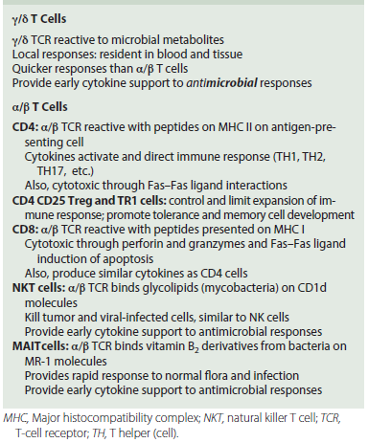

Major histocompatibility complex (MHC) restriction and antigen presentation to T cells. (A) Left, Antigenic peptides bound to class I MHC molecules are presented to the T-cell receptor (TCR) on CD8 T-killer/suppressor cells. Right, Antigenic peptides bound to class II MHC molecules on the antigen-presenting cell (APC) (B cell, dendritic cell [DC], or macrophage) are presented to CD4 T-helper cells. (B), T-cell receptor. The TCR consists of different subunits. Antigen recognition occurs through the α/β or γ/δ subunits. The CD3 complex of γ, δ, ε, and ζ subunits promotes T-cell activation. C, Constant region; V, variable region.

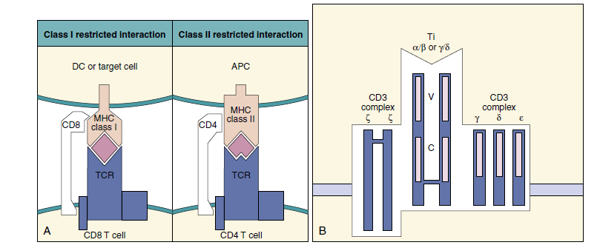

Structure of the embryonic T-cell receptor gene. Note the similarity in structure to the immunoglobulin genes. Recombination of these segments also generates a diverse recognition repertoire. C, Connecting sequences; J and D, segments; V, variable segments.
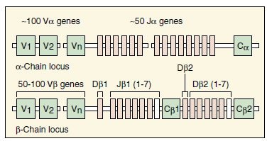

Activation pathways for T cells. Binding of major histocompatibility complex (MHC) II-peptide to CD4 and the T-cell receptor (TCR) activate kinase cascades and phospholipase C to activate the nuclear factor of activated T cells (NF-AT), nuclear factor-kappa B (NF-__), activation protein 1 (AP-1), and other transcription factors. APC, Antigen-presenting cell; DAG, diacylglycerol; GTP, guanosine triphosphate; IL-2, interleukin-2; IP3, inositol 1,4,5-triphosphate; Lck, lymphocyte-specific tyrosine protein kinase; MAP kinase, mitogen-activated protein kinase; PIP2, phosphatidylinositol 4,5-bisphosphate; PKC, protein kinase C; PLC-_, phospholipase C-_; ZAP, _-associated protein. (Modified from Helbert, M. 2017. Immunology for Medical Students, third ed. Elsevier, Philadelphia, PA.)
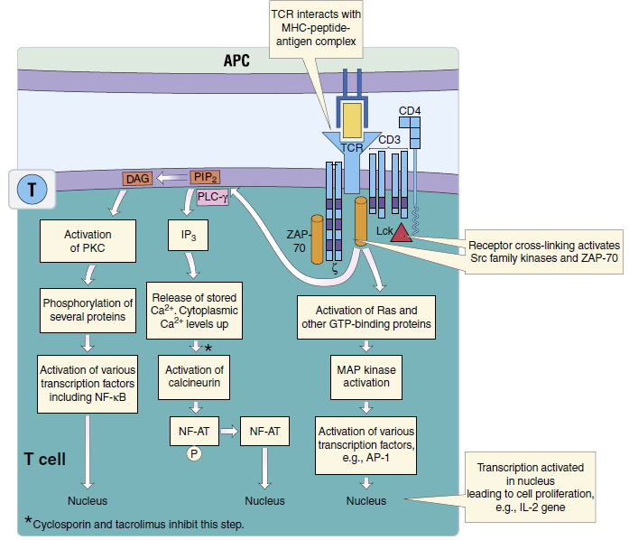

Accessory molecules expressed on the T-cell surface include several protein receptors that interact with their protein ligands on APCs and target cells leading to activation of the T cell, promotion of tighter interactions between the cells, or facilitation of the killing of the target cell. These accessory molecules are as follows:
1. CD45RA (native T cells) or CD45RO (memory T cells): a transmembrane protein tyrosine phosphatase (PTP).
2. CD28: cytotoxic T-lymphocyte–associated protein 4 (CTLA-4), PD-1, and ICOS-1 (inducible T-cell co-stimulator) bind to proteins of the B7 (B7-1, B7-2, PD-L1, PD-L2, L-ICOS) check point regulator family of proteins to deliver a co-stimulation or inhibitory signal to the T cell.
3. CD154 (CD40L): this is present on activated T cells and binds to CD40 on DCs, macrophages, and B cells to promote their activation.
4. FasL: this initiates apoptosis in a target cell that expresses Fas on its cell surface.
Adhesion molecules tighten the interaction of the T cell with the APC or target cell and also may promote activation. Adhesion molecules include leukocyte function–associated antigen-1 (LFA-1), which interacts with the intercellular adhesion molecules (ICAM-
1, ICAM-2, and ICAM-3) on the target cell. CD2 was originally identified by its ability to bind to sheep red blood cells and promote sheep red blood cell rosettes around T
cells. CD2 binds to LFA-3 on the target cell and promotes cell-to-cell adhesion and T-cell activation. Very late antigens (VLA-4 and VLA-5) are expressed on activated cells
later in the response and bind to fibronectin on target cells to enhance the interaction.

Inducers and Cytokines of T-Cell Responses
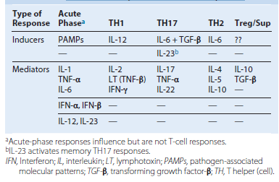

Human T-cell development. T-cell markers are useful for the identification of the differentiation stages of the T cell and for characterizing T-cell leukemias and lymphomas. TCR, T-cell receptor; TdT, cytoplasmic terminal deoxynucleotidyl transferase.
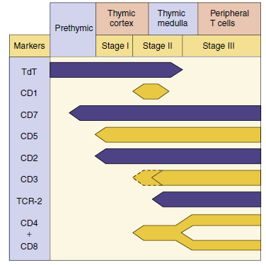

Activation of T-Cell Responses
Only a DC can initiate a response from a naive CD4 or CD8 T cell.
CD4
Antigen-presenting cells present 11 to 13 amino acid peptides on MHC II.
Coreceptor (B7.1 or B7.2) interacts with CD28 to activate or CTLA4 to suppress response.
Cytokines activate and determine the nature of the response.
CD40L expression and binding to CD40 on APC is necessary for APC activation.
Activation of cell changes chemokine receptors and adhesion proteins, and it enters blood and cycles through skin, tissue, and B-cell zones of lymph node.
CD8
DC activates CD8 T cell with help from CD4 T cell.
CD8 T cell enters blood and cycles through skin and tissue.
Target cell presents 8 to 9 amino acid peptides on MHC I.
Adhesion proteins create immune synapse.
Perforin and granzyme are secreted into immune synapse.
Target cell commits apoptosis.
APC, Antigen-presenting cell; CTLA4, cytotoxic T-lymphocyte–associated protein 4; DC, dendritic cell; MHC, major histocompatability complex.

Structure of class I and class II major histocompatibility complex (MHC) molecules. The class I MHC molecules consist of two subunits, the heavy chain, and $β$ 2-microglobulin. The binding pocket is closed at each end and can only hold peptides of 8 to 9 amino acids. Class II MHC molecules consist of two subunits, $α$ and $β$, are open at the ends, and hold peptides of 11 or more amino acids.
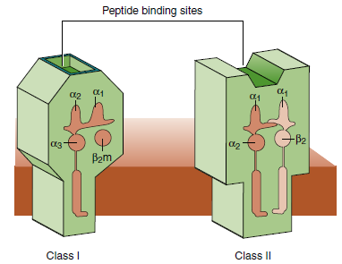

Antigen presentation. (A) Endogenous: Endogenous antigen (produced by the cell and analogous to cell trash) is targeted by attachment of ubiquitin (u) for digestion in the proteasome. Peptides of eight to nine amino acids are transported through the transporter associated with antigen processing (TAP) into the endoplasmic reticulum (ER). The peptide binds to a groove in the heavy chain of the class I major histocompatibility complex (MHC) molecule, and the β2-microglobulin (β2m) binds to the heavy chain. The complex is processed through the Golgi apparatus and delivered to the cell surface for presentation to CD8 T cells. (B) Exogenous: Class II MHC molecules assemble in the ER with an invariant chain protein to prevent acquisition of a peptide in the ER. They are transported in a vesicle through the Golgi apparatus. Exogenous antigen (phagocytosed) is degraded in lysosomes, which then fuse with a vesicle containing the class II MHC molecules. The invariant chain is degraded and displaced by peptides of 11 to 13 amino acids, which bind to the class II MHC molecule. The complex is then delivered to the cell surface for presentation to CD4 T cells. (C) Cross-presentation: Exogenous antigenic peptides transit from the phagosome to the ER of dendritic cells and is presented on MHC I molecules to CD8 T cells.

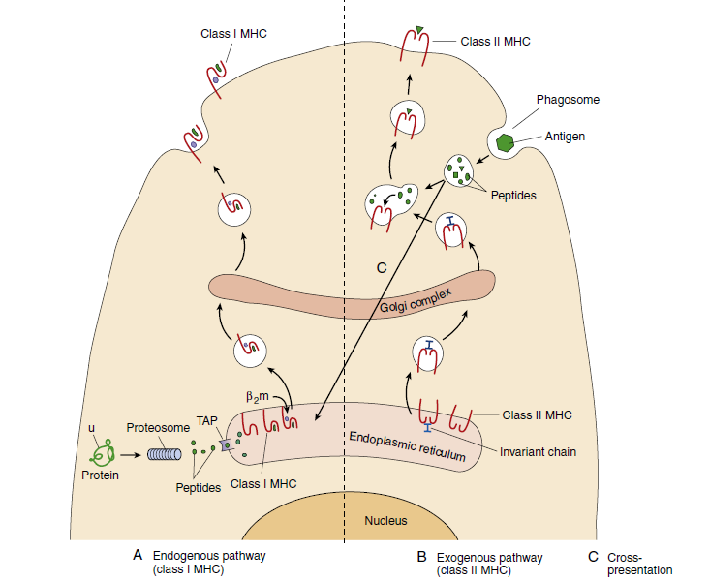

Molecules involved in the interaction between T cells and antigen-presenting cells (APCs). (A) Initiation of a T-cell response. CD4 T cells interact with major histocompatibility complex (MHC) II and its peptide and co-stimulatory/inhibitory ligands on dendritic cells (DCs). Initiation of a CD8 T-cell response is similar, but CD8 and the T-cell receptor (TCR) interact with peptide MHC I and the peptide it holds. (B) CD4 T-cell helper activation of a B cell, DC, or macrophage. CD40L–CD40 interaction activates the APC. (C) CD8 T-cell binding to target cell creates an immunosynapse into which perforin and granzymes are secreted. Cell-surface receptor-ligand interactions and cytokines are indicated with the direction of their action. Ag, Antigen; APC, antigen-presenting cell; CTLA4, cytotoxic T lymphocyte A4; ICAM-1, intercellular adhesion molecule-1; LFA-1, leukocyte function–associated antigen-1 TH, T helper.
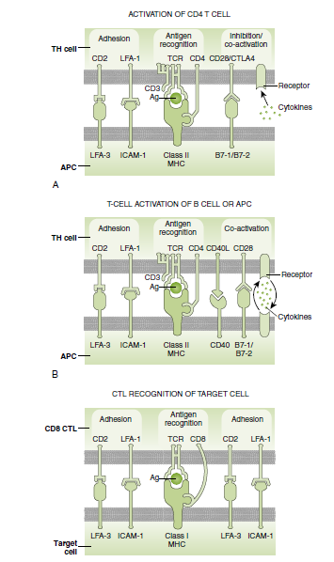

Progression of naive T-cell activation and response. (A) Interaction with antigen and coreceptors from the antigen-presenting cell (APC) activates expression of new transcription factors (c-Fos), interleukin (IL)-2, and the IL-2R to promote growth and CD40L to activate the APC. (B) CD4 or CD8 T-cell numbers rise rapidly in response to infection, after which the activated effector T cells will apoptosis, leaving memory T cells. Subsequent activation of memory T-cell responses is quicker.
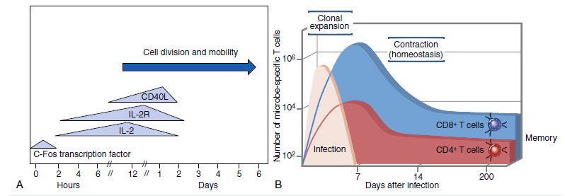
T-Helper Responses and Their Cytokines
Activated TH cells express CD40L to activate B cells, macrophages, and DCs.
TH cells produce growth-stimulating and response-defining cytokines.
Growth-stimulating cytokines: GM-CSF, IL-3
TH1: requires induction with IL-12, T-bet transcription factor
IFN-: activates CD8 T cells, M1 (inflammatory) macrophages; promotes B-cell production of IgG; inhibits TH2
IL-2: promotes T-, B-, and NK-cell growth
TNF-: promote inflammation and cytotoxicity
TH2: induced by IL-4, GATA-3 transcription factor
IL-4: T-cell growth factor, stimulates immunoglobulin class switch (IgG, IgE), activation of mast cells, M2 (alternative) macrophage
IL-5: B-cell and eosinophil growth factor, stimulates immunoglobulin class switch (IgG, IgA)
IL-10: B-cell growth factor and inhibitor of TH1 and inflammatory responses
TH17: induced by TGF-_ + IL-6; memory T cells by IL-23, ROR-_t transcription factor
IL-17: activates neutrophils, monocytes
IL-22: stimulates epithelium to grow and produce antimicrobial peptides
TFH: influenced by TH1 or TH2 cytokines
IL-21: germinal center development, plasma cell and memory B-cell development
IFN- or IL-4: see previous mention
Treg: requires IL-2, FoxP3 transcription factor
TGF-: inhibits naïve T-cell and other T-cell activation, inhibits inflammation
IL-10: see previous mention

T-cell responses are determined by cytokines. Dendritic cells initiate and determine the type of CD4 T-cell responses by the cytokines they produce. Similarly, T cells use other cytokines to tell other cells what to do. The response-defining cytokines are indicated. ↑, Increase; ↓, decrease; CTL, cytotoxic T lymphocyte; IFN-γ- interferon; IgG/IgE/IgA, immunoglobulin G/E/A; IL, interleukin; TGF- transforming growth factor; TH, T helper (cell); Treg, T regulator cells.

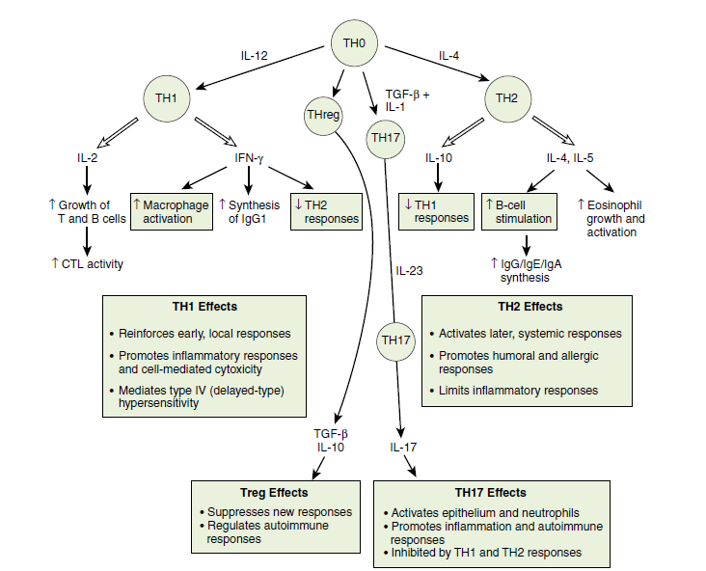

DCs, Dendritic cells; GM-CSF, granulocyte-macrophage colony-stimulating factor; IFN, interferon; Ig, immunoglobulin; IL, interleukin; TFH, follicular helper T cell; TGF, transforming growth factor; TH, T helper; TNF, tumor necrosis factor; Treg, T regulator cell.

